EXP 15 Design a two conductor transmission line and examine the impact of conductor dimensions on characteristic Impedance and Propagation Velocity

OUTPUT
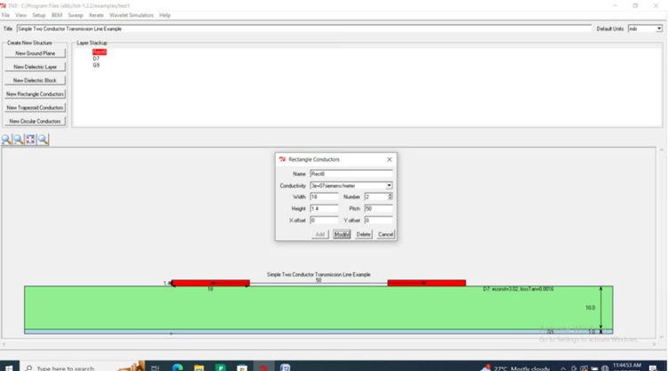

EXP 16 Design a two conductor transmission line and examine the impact of Dielectric layer material on characteristic Impedance and propagation Velocity
OUTPUT
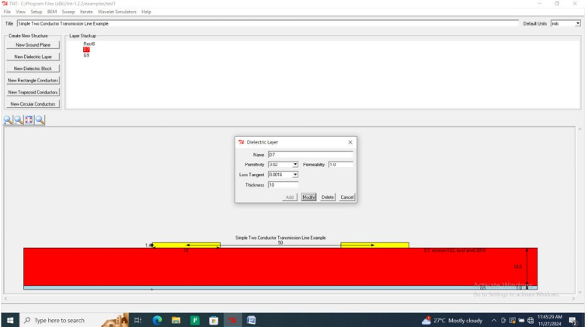
EXP 9 Calculation of Group velocity, Phase velocity and phase constant of EM waves in rectangular waveguides
PROGRAM CODE
Experiment 9
Test Case 1
PROGRAM:

clc;
clear;
close;
//TE10 Mode
a=8.636*10^-2;
b=4.318*10^-2;
f=4*10^9;
V=3*10^8;
m=input("enter the value of m= "); n=input("enter the value of n=
fc=(V/(2*3.14))*sqrt((m*3.14/a)^2+(n*3.14/b)^2);
disp("Cut off frquency=",fc*10^-9);//let phase velocity = A
A=V/sqrt(1-(fc/f)^2);
disp("Phase velocity in Mm/sec=",A*10^-6);
//let group velocity = B
B=V*V/A;
disp("Group velocity in Mm/sec =", B*10^-6);

OUTPUT


